*SPORTEE*

specifications

Contents

OVERVIEW 1

PROJECT TEAM 1

GOALS 1

PHASES 2

FUNCTIONALITY 2

Website 2

SITE MAP 2

PAGE TEMPLATE 3

Web application 3

USER STORIES 3

APPLICATION MODULES 5

# OVERVIEW

The app is needed for a better administration of a sport center, that will generate increasing number of clients and an increased revenue.

The application is built from scratch and will include a web site and a web application.

# PROJECT TEAM

Raluca Rosu – [roxanamustata@yahoo.com](mailto:roxanamustata@yahoo.com)

# GOALS

* Increase gym classes subscriptions by 10%
* Increase personal trainer subscriptions by 25%

# PHASES

Phase 1 – Basic website, web application (current project)

Phase 2 – Integration of multilingual capabilities, payment gateways

Phase 3 – Mobile application

# FUNCTIONALITY

*The project includes a presentation website for the gym center and a web application with custom modules for each type of user (admin, member, trainer).*

## Website

* presentation of the gym center,
* gym classes,
* personal trainers,
* timetable,
* contact information,
* membership (sign up/in)

### SITE MAP

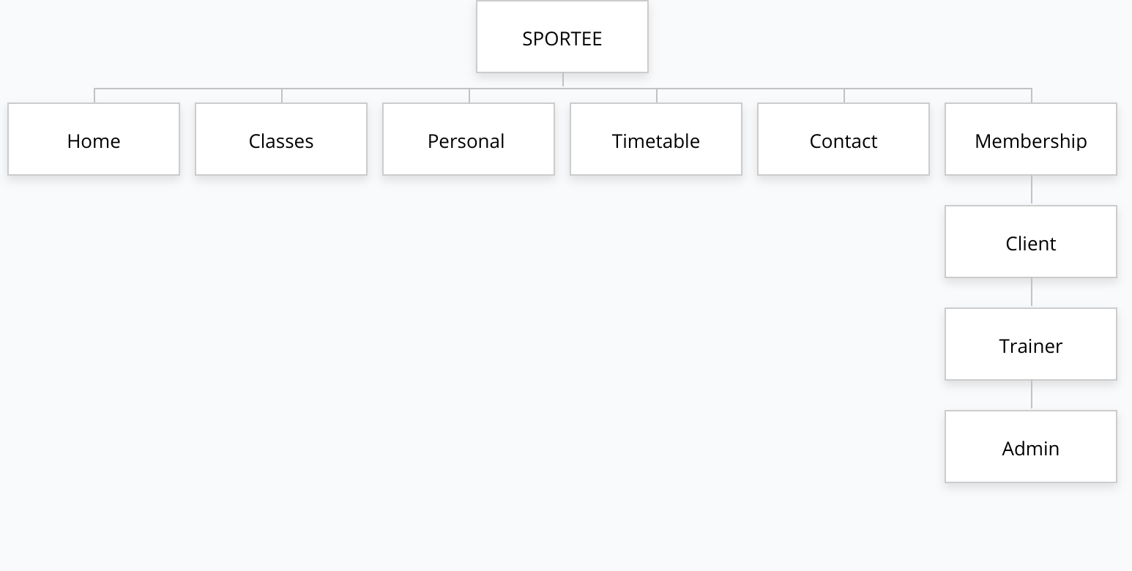

### PAGE TEMPLATE

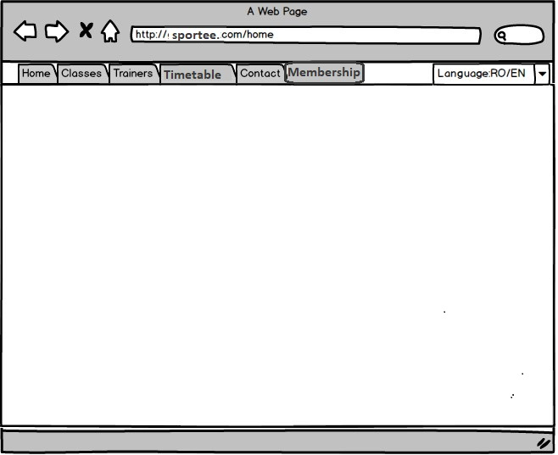

## Web application

### USER STORIES

User Registration

In order to have access to web application, you need to create a user (user name + password). After having the account created, you have to fill in your first name, last name, birth date, address, medical issues.

There will be three types of users: **admin, client and trainer**.

Each type of user will have a different role, with different rights.

Admin Portal

The admin gives roles to trainers and clients.

From the admin portal, the admin will give rights/unlock certain sections as follows:

* *For clients*: can make class reservations when the gym classes subscription is valid
* *For trainers*: can register the client measures and can add reservation for its clients (with a valid personal trainer subscription)
* *For admin*: can add/update the timetable (classes), can validate the clients’ subscriptions after payments are confirmed, can assign the role to the trainer.

Timetable

When choosing timetable from the menu, a page containing a table with seven columns (the days) and 12 rows (the hours of the day when the sport center is opened) will open, and in each cell there will be details about the class, the trainer and the duration of the class, and a button named “Reservation”. For one gym class there can be only 15 reservations (the capacity of the room where the classes take place).

The starting point for generating the monthly timetable is the gym classes timetable. The admin can choose to generate a new timetable. The admin will generate by the end of the current month the timetable for the next month. The current timetable can be used as template for the next month. During the current month the admin can also update the timetable.

Only after the monthly gym classes timetable is generated by the admin, the personal trainers can add their own reservation for personal training classes. The admin will also have this right. For one hour on the timetable there can be one gym class and one personal training class, because the sport center has 2 room dedicated for these activities.

Subscription

If you are a client, you can select from the subscriptions menu a subscription type and the starting date of the subscription. A message will confirm the subscription and will tell that it will be validated at the reception after confirmation of payment. Only after that validation, you can start making online reservation to classes.

Class reservation

If you have a valid subscription, you can make a reservation and the reservation will appear in section MyTimetable.

Personal trainer reservation

Trainer can check its schedule to see when he is booked for classes and can register the reservations for personal training, by choosing from the timetable an available hour.

Measurements registration

Trainer can also register the evolution of each client, meaning that he can save the measures for a certain client at a certain date. He can also print out reports that show client’s evolution in time. Client can also check his evolution in MyProgress.

### APPLICATION MODULES

#### ADMIN MODULE

|  |  |
| --- | --- |
| **ROLES** | **TIMETABLE** |
| Give roles to trainers | Create/update timetable for next/current month |
| Validate client subscription | Make class/personal trainer reservations |
|  |  |

#### CLIENT MODULE

|  |  |  |  |
| --- | --- | --- | --- |
| **MyTIMETABLE** | **MyPROGRESS** | **MySubscription** | **Contact trainer** |
| Check timetable and own reservations (class and trainer) | Check measures evolution in time (weight,…) | Check current subscription | Check trainers’ contact details |
| Make reservation to gym class |  | Make new subscription | * Phone * Email |
|  |  |  |  |

#### TRAINER MODULE

|  |  |
| --- | --- |
| **MyTimetable** | **Member Progress** |
| Check timetable and own reservations (class and trainer) | Check client’s measures evolution in time |
| Add new reservation for personal training | Record a new measurement for a client |